It is the Home team’s responsibility to prep the field for the game, and rake it after the game.

Prepping Procedure (Pre-game):
Rake Pitchers Mound (if needed)
Rake around bases to fill low points (if needed)
Line base path.
Use string located in sheds and make a line from the point of home plate to the outfield, The line should pass inside the 1st and 3rd base bags (see below).

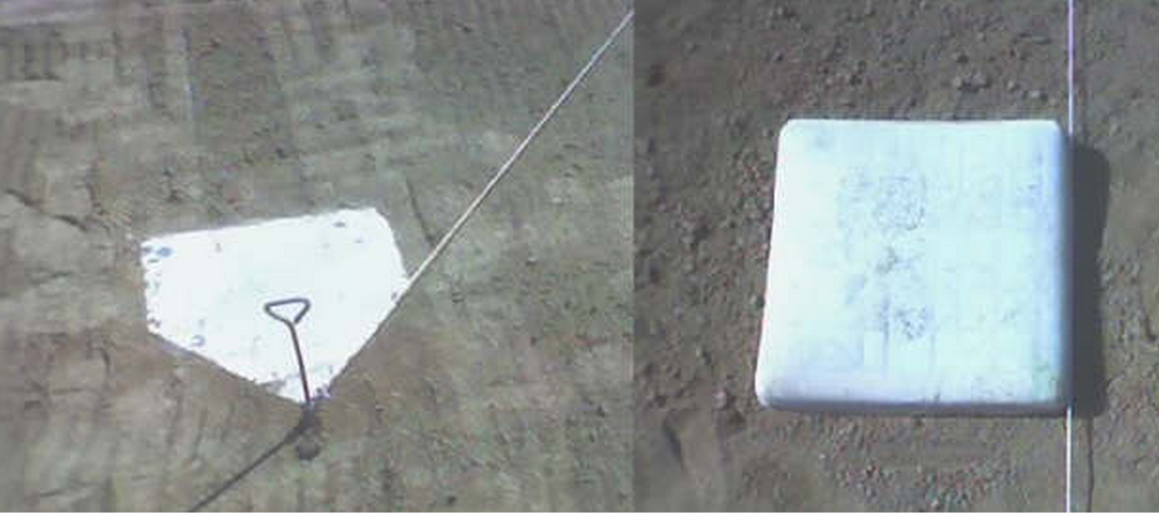

After the Game:
Base lines brushed to remove chalk.
** Do not rake or brush side to side, this build a valley in the baseline. Brush the line up and down from the base to home plate.
Rake around the bases to level the infield.
Drag the infield.
Rake and tamp the pitcher’s mound and batter’s box.

